<https://careercup.com/page?pid=facebook-interview-questions>

1. Given a list of Contacts, where each contact consists of a contact ID and a list of email IDs. Output a unique list of contacts by removing duplicates. Two contacts are considered to be the same, if they share at least one email ID.

2. Given an integer, print an English phrase that describes the integer (eg, "Two hundred and thirty four", “One Thousand, Two Hundred and Thirty Four”)

3. You are given n points (x1, y1), (x2, y2), ..... (xm, ym) of a two dimensional graph. Find 'n' closest points to (0,0) [ n <= m ]. Euclidean distance can be used to find the distance between 2 points.

4. write a class that 1) calculates the average of the stream, 2) provides an API read the average. Handle overflows as the numbers can be very large and not fit into double/long.

5. Given an array of lower case strings, the task is to find the number of strings that are special equivalent.
Two strings are special equivalent if they can be made equivalent by performing some operations on one or both string.

swapEven : swap a character at an even-numbered index with a character at another even-numbered index

swapOdd : swap a character at an odd-numbered index with a character at another odd-numbered index

Input : arr = {"abcd", "cbad", "bacd"}

Output : 2

The 2nd string can be converted to the 1st by swapping

the first and third characters. So there are 2 distinct

strings as the third string cannot be converted to the first.

string input[] = {"abcd", "acbd", "adcb", "cdba", "bcda", "badc"};

ans =4

遍历一遍，把每个string的奇、偶数位的单独摘出来重新排序后组成一个一个的substring，把这些subtring放入map<string,id>中，然后比较一遍，如果奇偶的string都相等那么这就符合条件，个数加一；

6. Give a binary tree, find if it's possible to cut the tree into two halves of equal sum. You can only cut one edge.

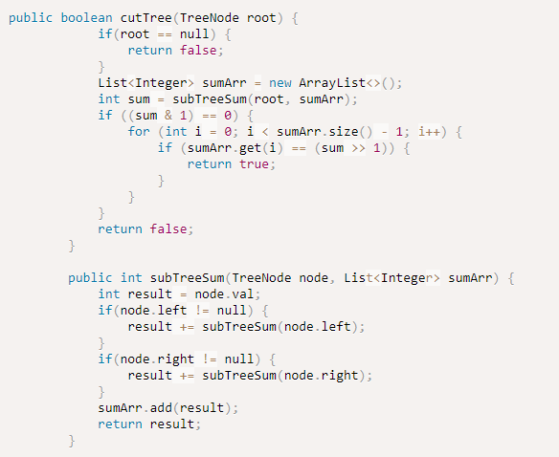

7. Given 2 strings representing very large numbers (these are not representable as a BigInteger or other various type) write a method for adding the two numbers and returning their sum.

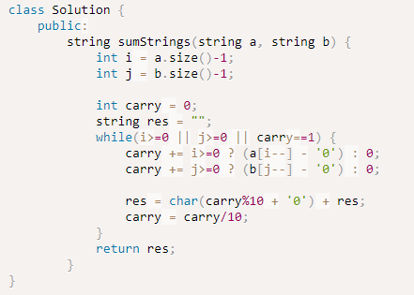

8. word look up

9.

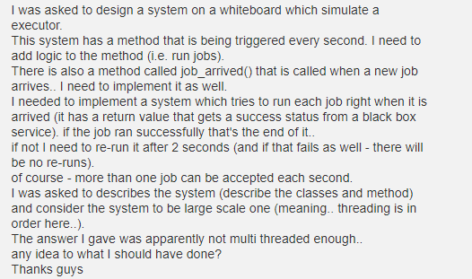

10.

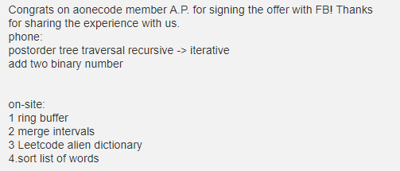

(1)alien dictionary:

There is a new alien language which uses the latin alphabet. However, the order among letters are unknown to you. You receive a list of words from the dictionary, wherewords are sorted lexicographically by the rules of this new language. Derive the order of letters in this language.

For example,

Given the following words in dictionary,

[
"wrt",
"wrf",
"er",
"ett",
"rftt"
]

The correct order is: "werft".

Note:

You may assume all letters are in lowercase.

If the order is invalid, return an empty string.

There may be multiple valid order of letters, return any one of them is fine.

11.

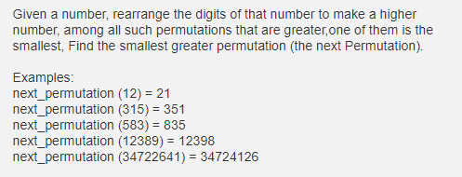

5120

scan the number from right to left, exchange the adjacent two bit number if find the two numbers which the right one is bigger than the left one.

12. Given a binary tree, where each node represents an integer, find the max value of path sum.

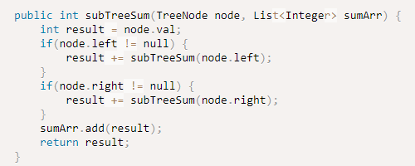

calculate each sum of subtree and stored in the sumArr, then sort the sumArr.(because there maybe some negtive numbers in the tree)

13.

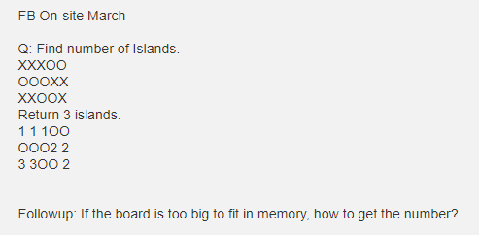

14.

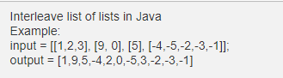

15.

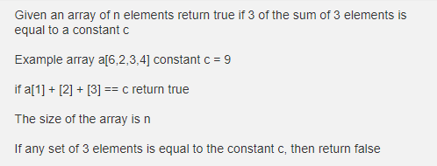

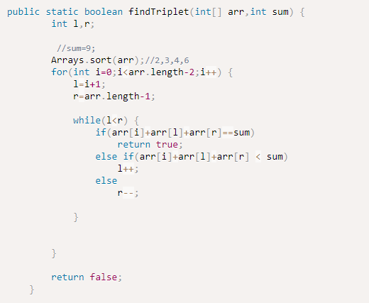

16.Given a string with alpha-numeric characters and parentheses, return a string with balanced parentheses by removing the fewest characters possible. You cannot add anything to the string.

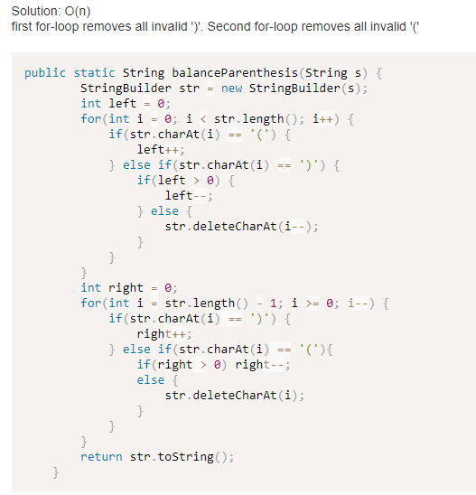

17.

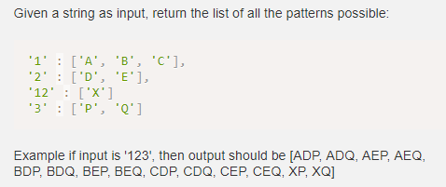

18.

Move[inplace] the non zero elements at the one end(end of array) and return the numbers of non zero elements in output array

19.

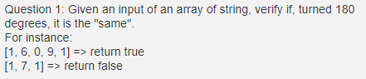

20.

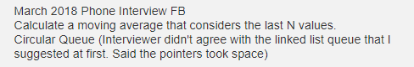

21.

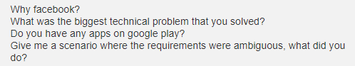

22.

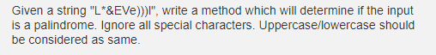

23.

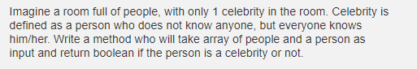

24.

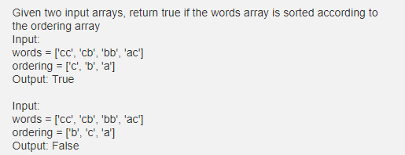

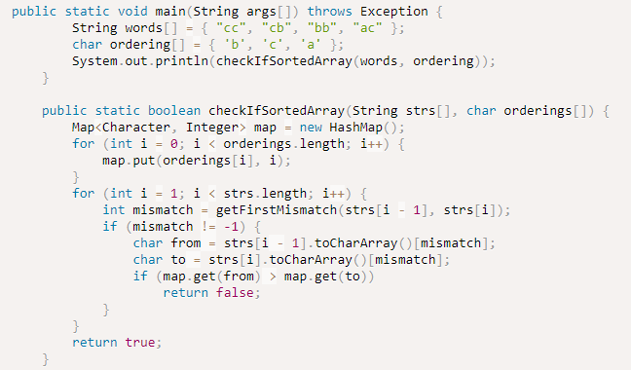

public static int getFirstMismatch(String str1, String str2) {
char elem[] = str1.toCharArray();
char elem2[] = str2.toCharArray();
return IntStream.range(0, min(elem.length, elem2.length)).filter(temp -> elem[temp] != elem2[temp]).findFirst()
.orElse(-1);
}

25.

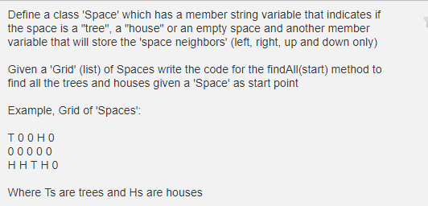

26.

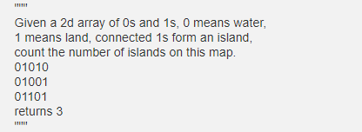

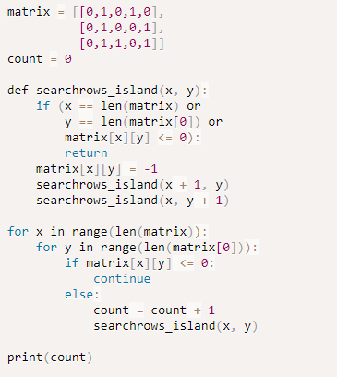

27.

